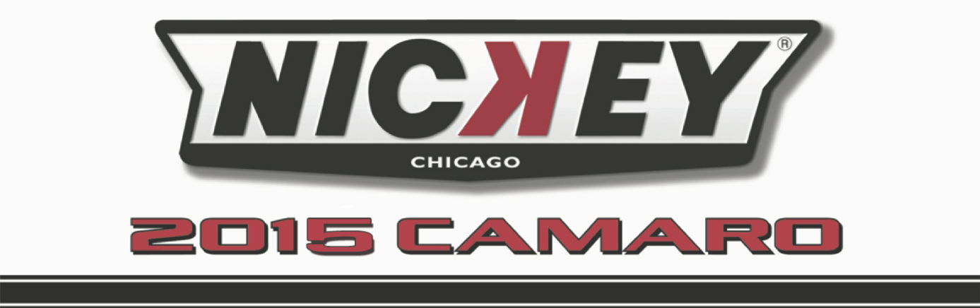

Dealership Name: V.I.N.
2G1FK3DJ9F9123862
Todd Wenzel Chevrolet
3156 Highland Drive
Hudsonville, MI 49426

Red NicKey Super Camaro #CV15014
White Leather Interior

NicKey Super Camaro Convertible Stage I 500hp

NicKey Chicago Stage I Base Option_____________________________________________________$12,580.00

- NicKey Registry Serialized & Certified  - VIN # Maintained in Supercar Registry  - Special “Built For” Customer I.D. Plate  - NicKey Badges & Emblems  - NicKey Door Sill Plates  - NicKey Chrome Torque Thrust Wheels $1,895.00  - NicKey Billet Center Caps $ 250.00  - Red Brake Calipers $ 750.00  - Drilled & Slotted Brake Rotors $1,000.00  - NicKey Valve Covers $750.00  - NicKey Red Plug Wires $100.00 | - NicKey Premium Floor Mats  - NicKey Logo Headrests  - 160 Degree Thermostat  - NicKey Premium Leather Interior $ 2,675.00  - NicKey Upgraded Stripe Pkg $ 650.00  - 3” Stainless Magnaflow Exhaust $2,100.00  - NicKey Stinger Hood, Painted $3,000.00  - Lowering Coils $750.00  - Custom Paint Door Panels/Dash $895.00  - Custom Paint Tonneau Cover $595.00  - Painted Roto Fab Cold Air $150.00  - Oil Catch Can $300.00

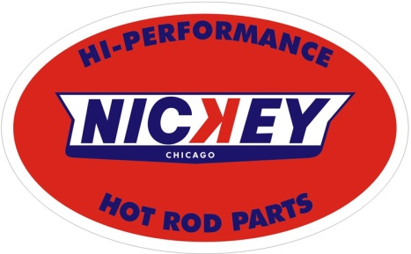 | Base Camaro GM MSRP_________________ $47,415.00  NicKey Chicago Options Price ________________ $28,440.00  Total Vehicle MSRP_________________________$75,855.00

