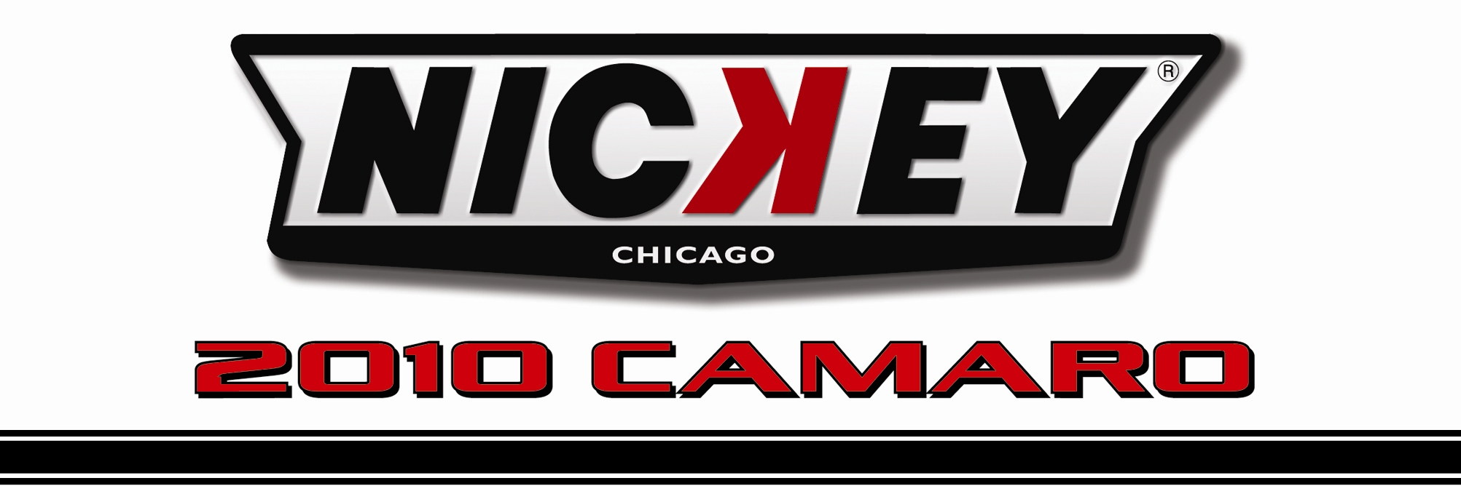

Dealership Name: V.I.N. Number:
2G1FT1EWXA9107206
Todd Wenzel Chevrolet
3156 Highland Drive
Hudsonville, MI 49426

Red Jewel Tintcoat NicKey Super Camaro #10002
Buckskin & Red Interior

NicKey Super Camaro Stage II SE
(Supercharged 50 states emissions legal)

NicKey Chicago Stage II Base Option__________________________________________________$18,690.00

- NicKey Registry Serialized & Certified  - VIN # Maintained in Supercar Registry  - Special “Built For” Customer I.D. Plate  - NicKey Badges & Emblems  - NicKey Magnuson Super Charger/Chrome  - NicKey/Magnuson Specs Computer Programming  - Torque Thrust Wheels/Chrome $1,800.00  - Red Line Nitto Tires $1,780.00  - NicKey Billet Center Caps $ 450.00  - NicKey Stinger I Hood/Painted $3,000.00  - Detroit Speed Lowering Kit $1,295.00  - NicKey Door Sill Plates $250.00  - Roto Fab CAI/Chrome Tube $750.00 | - NicKey Hood & Hockey Stick Stripes  - NicKey Premium Floor Mats  - NicKey Premium Car Cover  - NicKey Logo Headrests  - 160 Degree Thermostat  - Cold Air Intake  - Magna Flow Exhaust $1,200.00  - NicKey Short Throw Shifter $ 500.00  - NicKey Gun Grip Handle $ 250.00  - NicKey Premium Leather Interior $2,500.00  - NoWeeds Exhaust Diverters $1,600.00  - Oil Catch Can $400.00

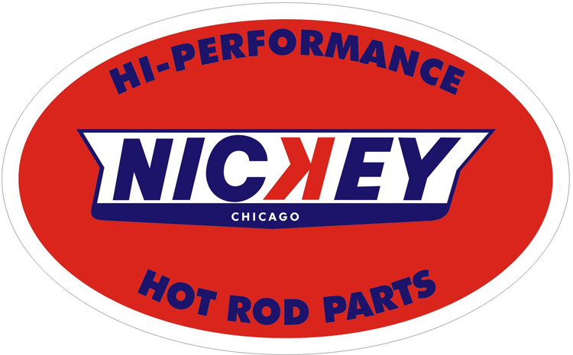 | Base Camaro GM MSRP_________________ $36,295.00  NicKey Chicago Options Price ________________$34,465.00  Total Vehicle MSRP_________________________$70,760.00

