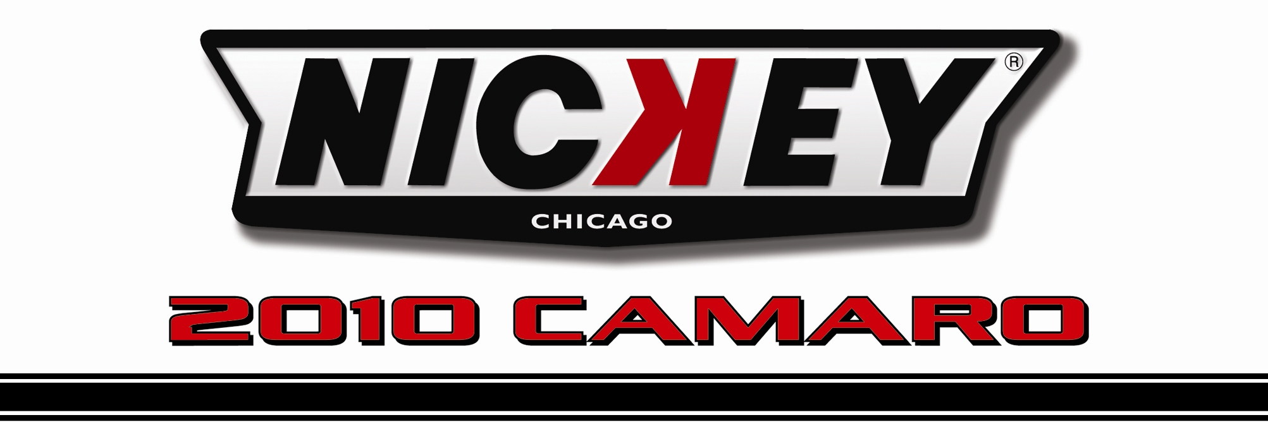

Dealership Name: V.I.N. Number:
2G1FJ1EJXA9198293
Todd Wenzel Chevrolet
Highland Ave
Hudsonville, MI

Cyber Gray NicKey Super Camaro #10029
Black and Dove Gray Interior

NicKey Super Camaro Stage II

NicKey Chicago Stage II Base Option__________________________________________________$18,640.00

- NicKey Registry Serialized & Certified  - VIN # Maintained in Supercar Registry  - Special “Built For” Customer I.D. Plate  - NicKey Badges & Emblems  - NicKey Head & Cam Package  - NicKey Specs Custom Dyno Tune  - NicKey Chrome Torque Thrust Wheels $1,895.00  - NicKey Door Sill Plates $ 250.00  - NicKey Billet Center Caps $ 250.00  - NicKey Stinger I Hood/Painted $3,000.00 | - NicKey Hood & Hockey Stick Stripes  - NicKey Premium Floor Mats  - NicKey Premium Car Cover  - NicKey Logo Headrests  - 160 Degree Thermostat  - MagnaFlow Exhaust $1,000.00  - NicKey Premium Leather Interior $2,125.00  - NicKey Logo Door Panels $ 250.00  - Detroit Speed Suspension $1,800.00

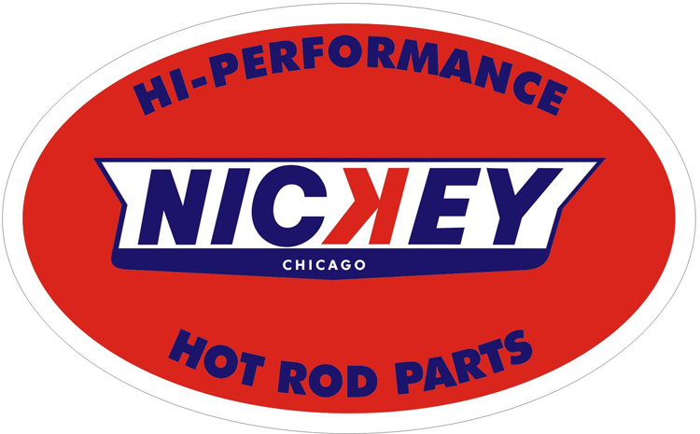 | Base Camaro GM MSRP_________________ $34,955.00  NicKey Chicago Options Price ________________ $29,210.00  Total Vehicle MSRP_________________________$64,165.00

